# BOOK BANK PROCESS

**USECASE DIAGRAM**

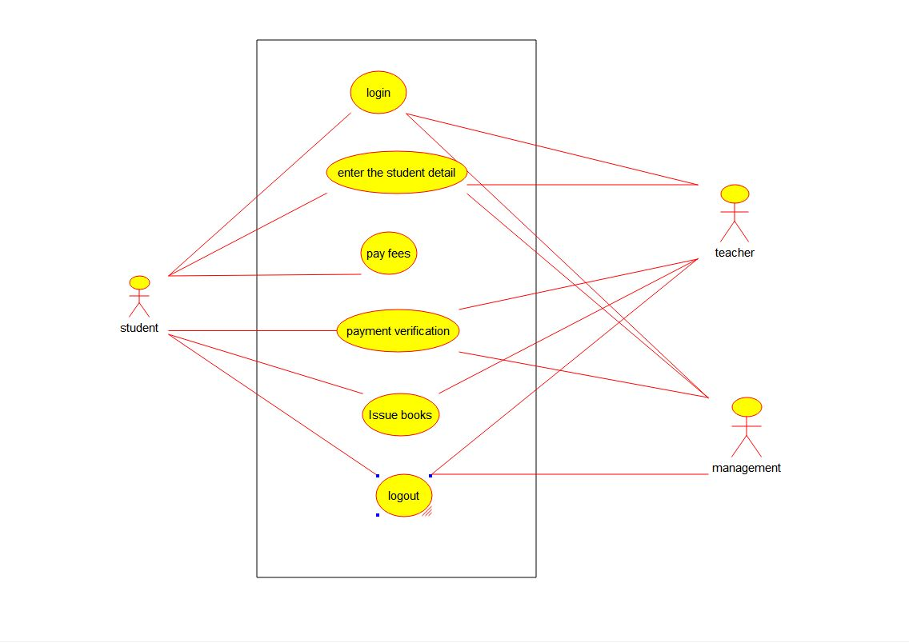

**STATE DIAGRAM**

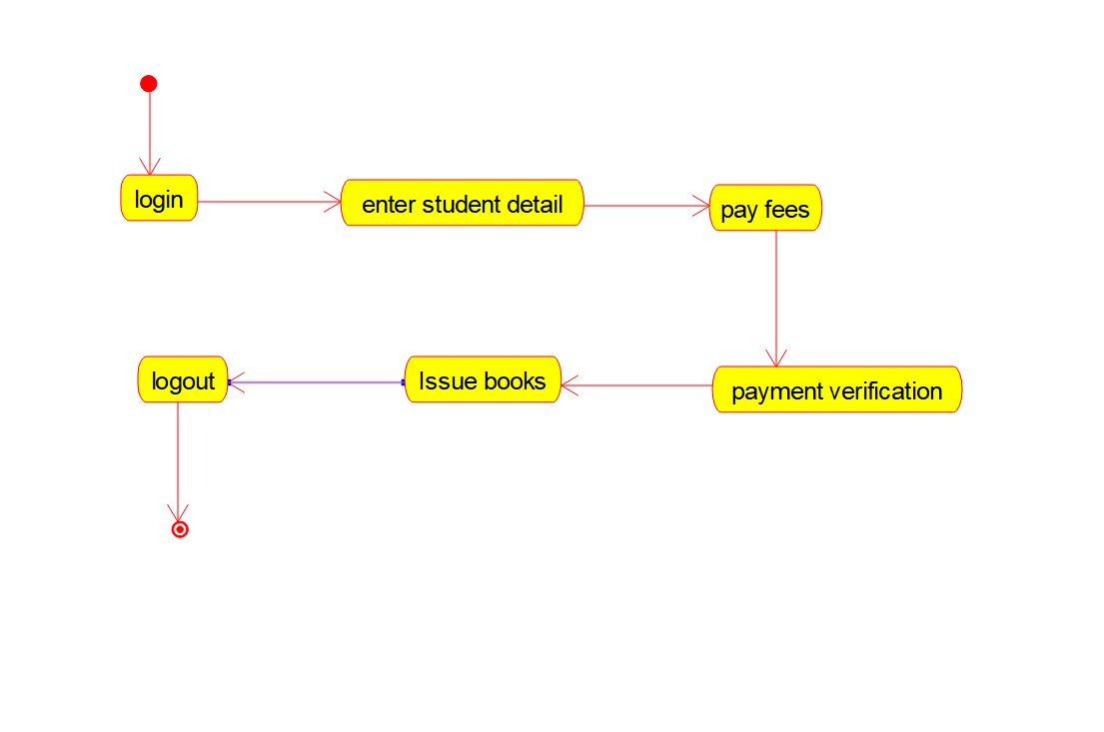

CLASS DIAGRAM

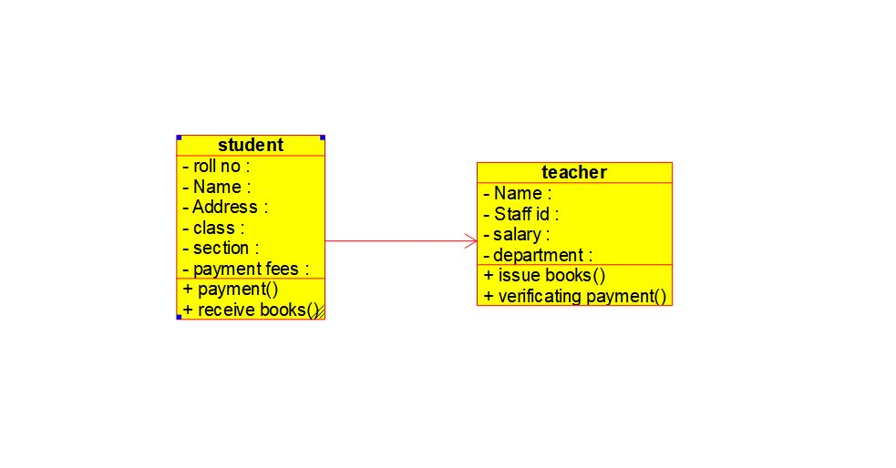

ACTIVITY DIAGRAM

